PROJECT REPORT

on

"Potholes Detection and Repairing**"**

By

Sahil Pandita 116A2083

Ashish Sahu 116A2085

Aadityanand 116A2097

Varun Walimbe 116A2118

UNDER THE GUIDANCE OF

**Prof. Shubhangi Kharche**

SUBMITTED IN PARTIAL FULFILLMENT FOR THE DEGREE OF

BACHELOR OF ENGINEERING

In

Electronics and Telecommunication



**DEPARTMENT OF ELECTRONICS AND TELECOMMUNICATION**

**SIES GRADUATE SCHOOL OF TECHNOLOGY**

**NERUL, NAVI MUMBAI – 400706**

ACADEMIC YEAR

2019– 2020

**CERTIFICATE**

This is to certify that this is a bonafide record of Project Stage-I of the project titled **Detection and Correction of Potholes** carried out by the following students of final year in Electronics and Telecommunication.

Sr. No. Name Roll No.

1. Sahil Pandita 116A2083
2. Ashish Sahu 116A2085
3. Aadityanand 116A2097
4. Varun Walimbe 116A2118

The report is submitted in partial fulfillment of the degree course of Bachelor of Engineering in Electronics and Telecommunication,of University of Mumbai during the academic year 2019-20

**Internal Guide Head of Department Principal**

We have examined this report as per University requirements at SIES Graduate School of Technology, Nerul (E), Navi Mumbai on ____________.

**Name of External Examiner: ___________________________________________**

**Signature with Date: _____________________________**

**Name of Internal Examiner: ___________________________________________**

**Signature with Date: _____________________________**

**ACKNOWLEDGEMENT**

We wish to express our deep sense of gratitude to thank our project guide prof. Shubhangi Kharche providing timely assistant to our query and guidance. We take this opportunity to thank our HoD and Principal Dr. Atul Kemkar for their valuable guidance and immense support in providing all the necessary facilities.

We would also like to thank the entire faculty of ExTC Department for their valuable ideas and timely assistance in this project. Last but not the least , we would also like to thank teaching and non-teaching staff members of our college for their support, in facilitating timely completion of this project.

**Project Team**

**CONTENTS**

|  |  |  |
| --- | --- | --- |
| Sr.No. | Topic | Page No. |
| I | Abstract | 1 |
| 2 | Introduction | 2 |
| 3 | Need of P Literature Survey | 3-4 |
| 4 | Methodology | 5 |
| 5 | System Architecture | 6 |
| 6 | Hardware and Software components | 7-12 |
| 7 | References | 13 |

**ABSTRACT**

The system will count the number of potholes present on the roads where the system is installed and upload the data to the database in real time. This identification and counting will be done by using image processing techniques. After the data is uploaded on the database a bot will be deployed to the site where the pothole is identified, for the filling of the potholes. The pothole will be filled using thermosetting plastics for quick and efficient repairs. The idea is of filling the pot holes before they get any bigger than threshold size. Small potholes (12 inches diameter ,2 inches depth) can be easily fixed using the thermosetting plastic. The fixing of the pothole will be done by the automated bot and after the work is complete, the information will be updated in the system. For the bigger potholes already present, the image processing software will distinguish it from the smaller potholes to be fixed by the bot, and a message will be sent to the right authorities for the filling of the bigger potholes and once the fixing is completed the information will be uploaded in the database.

**INTRODUCTION**

Nowadays there is an exponential increase in the population of Mumbai. The commuters believe in commuting through Trains,bikes,cars etc.This has led to an increase in vehicles and resulting in the faster corroding of the roads. These roads,if left unattended cause traffic snarls,delays and accidents which can cause mental strain and in some cases fatality.

To reduce the potholes we have decided on a mechanism where it could simultaneously detect and store the data of the pothole in the database. For the transmission of data we would use LoRaWan module,which can send data to a maximum distance of few kilometers.Then it would send a robot without any manual assistance to that place to correct it by using thermosetting plastic instead of asphalt. This reduction of manual labour will also lead less in time consumption for the correction of pothole.

**Objectives**

The objective of this study is to firstly create a completely autonomous robot which can be deployed unmanned and automatically to the specific position.

Next it would check the depth and the width of the pothole using image sensors and finally fill it up with thermosetting plastics that will be heated by a heating object like blowtorch.

**LITERATURE SURVEY**

In all the previous papers published,we could see that there were various methods on detection of potholes and the different techniques used for that,but in here we are not only detecting but also correcting as soon as we can which others haven’t.

Mae M Garcillanosa et al[1] said that The smart detection and reporting of pothole system was able to operate successfully. The camera was efficiently used for the detection of potholes where several algorithms like erosion, dilation, Canny edge detection, and contouring were used for image processing. In general, the response time of the image-processing scheme was relatively fast. The deployment of automatic detection system did not use any laptop, desktop nor Smartphones and therefore proved to be portable since only the Raspberry Pi microcomputer, along with its modules, were used on the vehicle. This shows that the system was able to detect potholes and report them properly along with correct  
details about the pothole locations. The system produced an average accuracy, sensitivity, and specificity within the expected output and the success rate of sending reports of detection was found to have no errors. The value of the accuracy achieved during the testing showed that the systems was excellent in terms of the overall performance.

David H.Gill et al [2] presented with an integrated approach to roaddistress identification. The key to successful performance is a set of multiple algorithms working synergistically for a common goal. By adjusting algorithm complexity as a function of the size (pixel, subimage, or object) and the number of signals to be processed, we were able to achieve robust performance and computational tractability. Our future direction is transitioning algorithms to a. real-time processor while looking for additional opportunities in automatic target recognition, performance monitoring, medical image analysis, and shallow-water mine classification.

Su-il Choi et al [3] developed a pothole detection system using 2D LiDAR and camera. By using two LiDARs, wide area of the road surface can be scanned more accurately. Next, they developed pothole detection algorithm including filtering, clustering, line extraction and gradient of data function. Error rate of pothole detection system shows the performance of developed system. We also showed 3D pothole detection can be performed using 2D LiDAR. Pothole detection using video data is combined with that of 2D LiDAR, and combined data gives more accurate pothole detection performance.

Sudarshan S Rode et al [4] considered In this paper, they considered the problem of designing a novel Wi-Fi based infrastructure enabling application data transfer to the vehicles moving on the roads. This system can assist the driver in making strategic and real-time tactical decisions in varied environments. The detailed system design described in the paper explains the functions of two main components, access points and Wi-Fi equipped mobile nodes. The architectural design and system support for the pothole detection and warning system ensured that the driver gets information about potholes well in advance and has sufficient time to take decision according to the prevailing road conditions.

Shambu Hegde et al [5] discussed the problem of the pothole detection and inter vehicular communication. The proposed system uses the ultrasonic sensor for pothole detection and Zigbee module pair for communications. The proposed model uses NXP LPC 1768 microcontroller for taking decisions about controlling the speed of the vehicle. Our goal was to achieve the effective detection of pothole and communication between multiple vehicles. Effective detection of pothole is achieved. Even though we have established efficient communication between two vehicles, multivehicle communication could not be established. But with effective use of Zigbee protocol, communication between multiple vehicles can be achieved. Pothole detection is an important feature of the autonomous vehicles and this idea can be extended to detect vehicles in the vicinity and any type of obstacles on the road.

Leo Salavo et al [5] describes accelerometer data based pothole detection algorithms for deployment on devices with limited hardware/software resources and their evaluation on real world data acquired using different Android OS based smart-phones. The evaluation tests resulted in optimal setup for each selected algorithm and the performance analysis in context of different road irregularity classes show true positive rates as high as 90%.

Thus, we have seen all these papers that Image Processing is an integral part of the detection of Potholes. Plus, for the transmission of the images and data we are using LoRa instead of zigbee, as LoRa can transmit data over longer ranges i.e. ~ 10 kms. Also the project deals with the filling of potholes which hasn’t been attempted earlier on, here instead of asphalt we are using chip filling which can greatly reduce the recurring of the filling. Also by using chip filling techniques we can reduce the carbon emission by the production of asphalt resulting in a greener world and environment. The project will improve the efficiency of road maintenance and reduce the labor requirement for the same.

**METHODOLOGY**

**Support Vector Machine**

SVM is a model which can do linear classification and regression. SVM is based on the concept of a surface called hyper plane which draws boundary between data instances plotted in the multi dimensional feature space. SVM algorithm builds an N dimensional hyperplane model that assigns future instances onto one of the two possible output classes.

Support Vectors: Support vectors are the data points the critical points in the data set that are near the identified set of lines (Hyperplane ).If support vectors are removed they will alter the positions of the dividing hyperplane .

Margin:The maximum distance between the two classes and hyperplane is called margin.

Kernel:SVM has a trick to deal with non linearly seperable data called kernel trick.These functions transform the lower dimensional input space to higher dimensional space . In this process it converts non linearly seperable data to linearly seperable data.

TYPES OF KERNELS

→Linear Kernel

→Polynomial Kernel

→Sigmoid Kernel

→Gaussian RBF Kernel

WHY SVM ?

→SVM is perfectly meant for binary classification.

→it is robust ie not much impacted by data or outliers.

→The prediction results using this model are very promising.

SVM Algorithm

Step 1: selection of two classes on which classification has to be done.

Step2: Boundary plane is drawn between the two classes .(Hyperplane)

Step3:Find the Optimal hyperplane.

Step4: Data is classified using the correct hyperplanes and Input training data

**SYSTEM ARCHITECTURE**

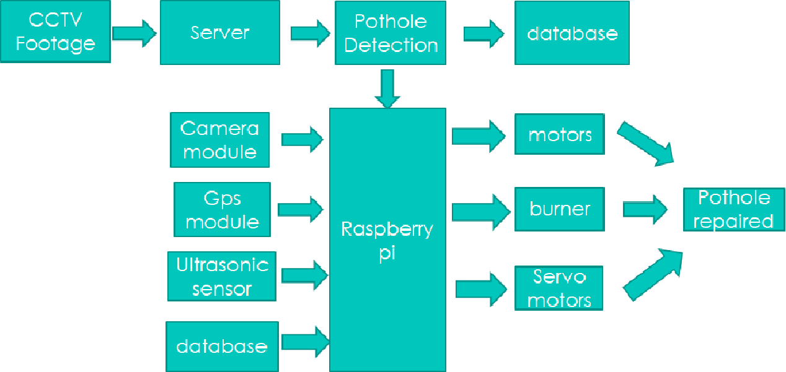

1. CCTV Footage:

→ The CCTV camera will be capturing the pictures of the condition of road periodically and it will send all the data to the server using LoRa.

1. Server:

→ The image received from the CCTV would be processed by the machine learning program and it will detect the potholes present in the photos.

1. Raspberry Pi:

→ It is the brain of the whole system. It helps in the navigation and controlling of the bot to go to the desired location and fix the pothole.

4. GPS Module:

→ It helps in the movement of the robot to the desired location using GPS. Location of the pothole will be given by the CCTV.

5. Ultrasonic Sensor:

→ It helps in finding the depth of the pothole, which helps in finding the desired amount of chipfill to be used for fixing it.

6. Motors:

→ It helps in the movement of the bot ,i.e, forward, backward, left and right.

7. Servo Motors:

→ It used to control the amount of chipfill material that is to be poured on the pothole.

8. Burner Module:

→ It is used in melting the chipfill material to fix the potholes accordingly.

**HARDWARE COMPONENTS**

1. RASPBERRY PI ZERO:

→The RaspberryPi Zero is a largely reduced size of only 65mm long by 30mm wide. With the addition of wireless LAN and Bluetooth, the Raspberry Pi Zero W is ideal for making embedded Internet of Things (IoT) projects. The Pi Zero is designed to be as flexible and compact as possible with mini connectors and an unpopulated 40-pin GPIO.At the heart of the Raspberry Pi Zero W is a 1GHz BCM2835 single-core processor with 512MB RAM. Raspberry pi zero will be the brain of the pothole repairing Robot. It will receive inputs from LoRa , motor driver and sensors and will control the robot based on the inputs from the devices.

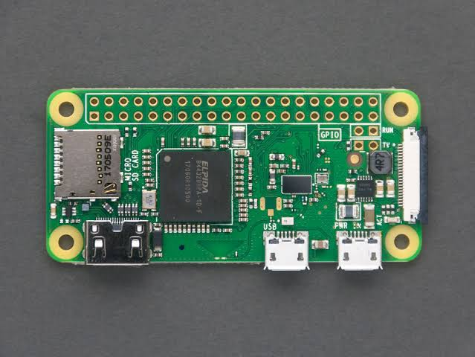

1. LoRa MODULE:

→LoRa is a '**Lo**ng **Ra**nge' low power wireless standard intended for providing a cellular style low data rate communications network.

The LoRa modulation and radio interface has been designed and optimized to provide exactly the type of communications needed for remote IoT and M2M nodes.LoRa module will used for wireless communication between the raspberry pi and the data transceiver. LoRa module will receive the data from the data transceiver (camera) and will supply it to Raspberry pi.

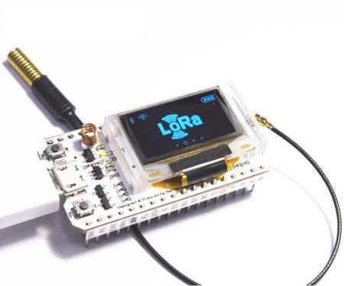

1. MOTOR DRIVER:

→The Motor Driver is a module for motors that allows you to control the working speed and direction of two motors simultaneously. DC motors requires 9v and more current that raspberry pi is not able to provide . Due to that motors cannot be controlled just by raspberry pi. So motor driver will be used to drive the motors that supplies enough current to them.

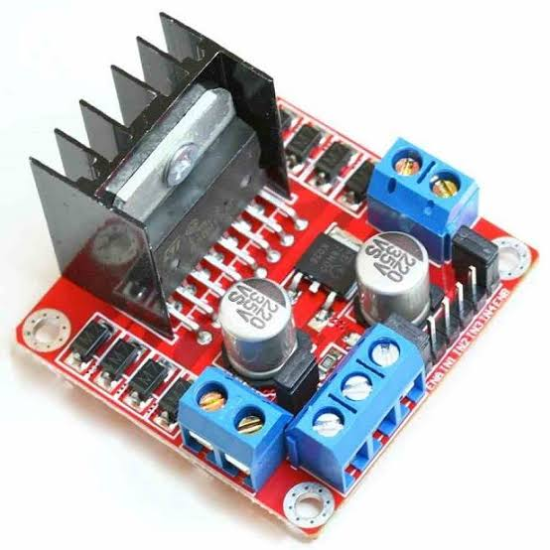

1. DC MOTORS:

→ DC motor is any of a class of rotary electrical machines that converts direct current electrical energy into mechanical energy. The most common types rely on the forces produced by magnetic fields. Nearly all types of DC motors have some internal mechanism, either electro-mechanical or electronic, to periodically change the direction of current flow in part of the motor.. DC motors will be used to drive the robot.

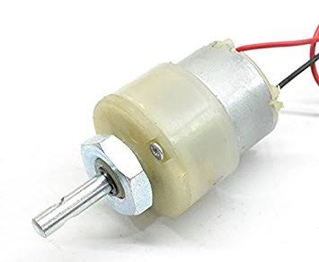

1. SERVO MOTOR:

→As we know that an electric motor can be utilized as servo motor if it is controlled by servo mechanism. Likewise, if we control a DC motor by means of servo mechanism, it would be referred as **DC servo motor**.The motors which are utilized as DC servo motors, generally have separate DC source for field winding and armature winding. The control can be archived either by controlling the field current or armature current. Field control has some specific advantages over armature control and on the other hand armature control has also some specific advantages over field control. Which type of control should be applied to the DC servo motor, is being decided depending upon its specific applications.This motor gives angular control of the shaft. So this will used to control the movement of burner that will be used to repair the pothole up and down.

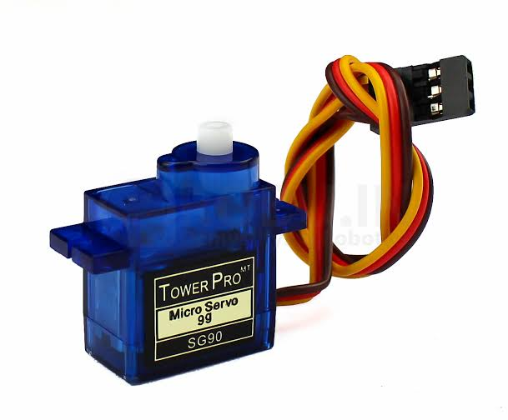

1. CAMERA MODULE:

→The **Pi camera module** is a portable light weight camera that supports Raspberry Pi. It communicates with Pi using the MIPI camera serial interface protocol. It is normally used in image processing, machine learning or in surveillance projects. It is commonly used in surveillance drones since the payload of camera is very less. Apart from these modules Pi can also use normal USB webcams that are used along with computer.. This Module will be used to detect a pothole on the road. Camera module will supply the necessary data required to detect a pothole.

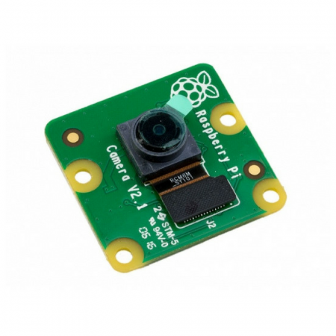

1. BURNER MODULE:

→This module will be used to melt the chip fill and fill the pothole.

.

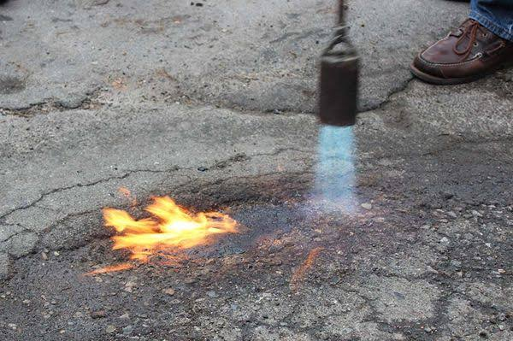

1. RELAY MODULE:

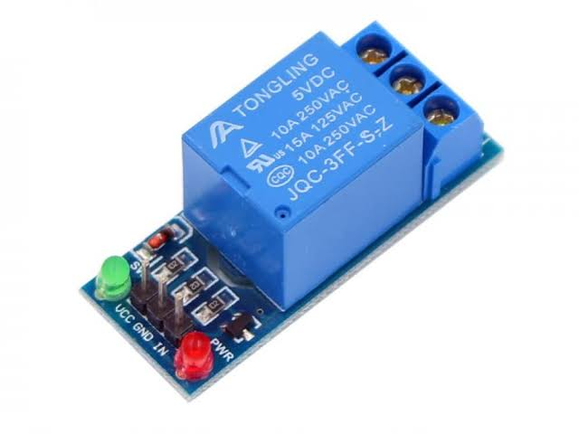

→A relay is an electrically operated switch. It consists of a set of input terminals for a single or multiple control signals, and a set of operating contact terminals. The switch may have any number of contacts in multiple contact forms, such as make contacts, break contacts, or combinations thereof.

Relays are used where it is necessary to control a circuit by an independent low-power signal, or where several circuits must be controlled by one signal. Relays were first used in long-distance telegraph circuits as signal repeaters: they refresh the signal coming in from one circuit by transmitting it on another circuit

. This module will be used to drive the burner as Rasberry pi would not be able to supply sufficient current to the burner to drive it.

**SOFTWARE COMPONENTS**

1. PYTHON IDLE 3.7.4

→IDLE (Integrated Development and Learning Environment) is an integrated development environment (IDE) for Python.

IDLE can be used to execute a single statement just like Python Shell and also to create, modify and execute Python scripts. IDLE provides a fully-featured text editor to create Python scripts that includes features like syntax highlighting, autocompletion and smart indent. It also has a debugger with stepping and breakpoints features.

1. JUPYTER NOTEBOOK

→The Jupyter Notebook is an open source web application that you can use to create and share documents that contain live code, equations, visualizations, and text.

Jupyter Notebooks are a spin-off project from the IPython project, which used to have an IPython Notebook project itself. The name, Jupyter, comes from the core supported programming languages that it supports: Julia, Python, and R. Jupyter ships with the IPython kernel, which allows us to write our programs in Python, but there are currently over 100 other kernels that we can also use.

**REFERENCES**

Mae M Garcillanosa “Smart Detection and Reporting of Potholes via Image-Processing using Raspberry-Pi Microcontroller”. DOI: [10.1109/KST.2018.8426203](http://dx.doi.org/10.1109/KST.2018.8426203)

[Conference: 2018 10th International Conference on Knowledge and Smart Technology (KST)](https://www.researchgate.net/conference-event/KST_International-Conference-on-Knowledge-and-Smart-Technology-10-2018_2018/92001)

2.David H.Gill “Automatic road distress classification and identification using hierarchial classifier and expert system”. NSPEC Accession Number: 5899897 DOI: [10.1109/ICIP.1997.638795](https://doi.org/10.1109/ICIP.1997.638795)

3.Su-il Choi “Pothole Detection System using 2D LiDAR and camera”.INSPEC Accession Number: 17063558 DOI: [10.1109/ICUFN.2017.7993890](https://doi.org/10.1109/ICUFN.2017.7993890)

4. Sudarshan S Rode “Pothole Detection and Warning System: Infrastructure Support and System Design”. INSPEC Accession Number: 10479675 DOI: [10.1109/ICECT.2009.152](https://doi.org/10.1109/ICECT.2009.152). [2009 International Conference on Electronic Computer Technology](https://ieeexplore.ieee.org/xpl/conhome/4795899/proceeding)

5. Shambu Hegde “Pothole Detection and Inter Vehicular Communication”. INSPEC Accession Number: 15001142 DOI: [10.1109/ICVES.2014.7063729](https://doi.org/10.1109/ICVES.2014.7063729). [2014 IEEE International Conference on Vehicular Electronics and Safety](https://ieeexplore.ieee.org/xpl/conhome/7055411/proceeding)

6. Leo Salavo “Real Time Pothole Detection using Android Smartphones with Accelerometers.” DOI: 10.1109/DCOSS.2011.5982206 · Source: [IEEE Xplore](https://www.researchgate.net/deref/http%3A%2F%2Fieeexplore.ieee.org%2Fxpl%2Ffreeabs_all.jsp%3Farnumber%3D5982206)

Conference: 2011 7th IEEE International Conference on Distributed Computing in Sensor Systems and Workshops (DCOSS)